**OMO_FAROU Calculations**

**Rectangle calculations:**

1. Angle of scan is given by the compass.
2. The angle is used to calculate the rectangle sides
3. The step is 30 degrees, and the diagonal of the rectangle is the distance from left sensor and right sensor added.
4. If for example the angle is 60 then the rectangle will be as shown in figure 1.0.

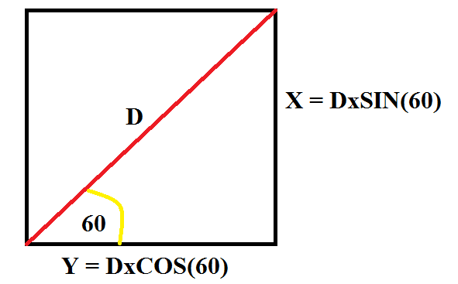

Figure 1.0

Wiring code Sheet:

<https://docs.google.com/spreadsheets/d/1iF4tBBPmonuHqM8vxqG8jTnHyGRIf22lDA3FOj3GoCs/edit#gid=0>